Digital Technologies & Hangarau Matihiko

Level 3, Two 4 Credit, Internal Assessments

Student Documentation

This document serves as evidence of your work for **AS 91902** & **AS 91903**

**AS 91902: Use complex techniques to develop a database**

**AS 91903: Use complex techniques to develop a digital media outcome**

# Introduction

This assessment activity requires you to plan, develop and create a complex computer program.

You will be assessed on

* How effectively you use project management tools and techniques to plan and manage the development of a digital outcome
* How effectively you decompose the problem into smaller components, and test and refine your media outcome so that it is a high-quality response to the task
* How well you have addressed relevant implications
* How well you synthesise information from the planning, testing and trialling of components to develop a high-quality response to the task (e.g. well-structured, logical, flexible, robust and comprehensively tested program)
* Discuss how this information assisted in the development of a high-quality outcome.

Table of Contents

Introduction 1

Database design: upload images or PDF of your Entity Relationship Diagram(s) (if you created multiple versions) 3

Database design: upload your Excel schema(s) (if you created multiple versions) 3

Relevant Implications 4

What tools and techniques did you use to design, develop, and test your digital media outcome? 4

If you added features to the website one-at-a-time, which features did you work on and in which order? 4

Iterative improvement: what improvements did you make with each iteration? 5

Decomposing the Outcome 6

Explain relevant implications 7

Sprint Tracking 1 9

Sprint Tracking 2 11

Sprint Tracking 3 13

Project Summary 15

# Database design: upload images or PDF of your Entity Relationship Diagram(s) (if you created multiple versions)

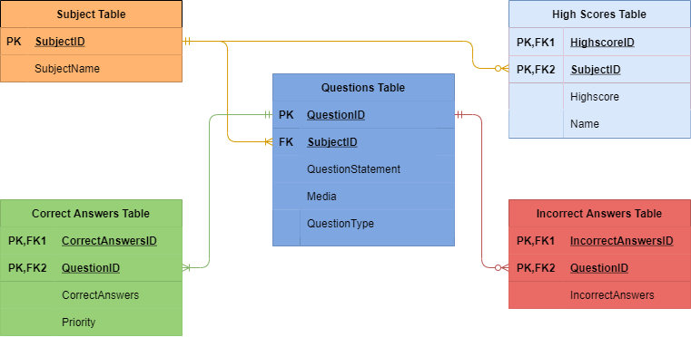

# Database design: upload your Excel schema(s) (if you created multiple versions)



# Relevant Implications

## Relevant implications: explain how you addressed a relevant implication in your outcome

I have followed Intellectual Property by:

* Sourcing all the quiz content from Matua Doc
* Sourcing the illustrations, fonts used from an open-source library
* Receiving permission to use the Onslow College Logo form Matua Doc

## Relevant implications: explain how you addressed another relevant implication in your outcome

I have followed Accessibility & Usability by:

* Contrast checking the colour scheme to make sure it is suitable for everyone
* Clearly followed database convention, labelling tables and rows appropriately

# What tools and techniques did you use to design, develop, and test your digital media outcome?

Through out the process of designing, developing, and testing my database I used a range of tools and techniques such as, Atom and VS Code as the text editor to write my code for which I used SQL. I also used draw.io as the tool to create my ERD and Excel to visualise and display all the data in their correct tables.

Testing the database included a lot of back and forth in phpMyAdmin manipulating queries to produce the desired results before testing them on my website.

# What tools and techniques did you use to design, develop, and test your digital media outcome?

Designing the outcome required me to use tools such as AdobeXD, Adobe Colour and Adobe Fonts. These tools were all very helpful in creating mock-ups of the site, displaying possible colour and/or font schemes respectively.

Like the database I started off using Atom as my text editor of choice, then moved to VS Code for the rest of the project. I did this as I realised VS Code had a wider range of tools that would help in the development of the outcome, especially while working with PHP, SQL, HTML, CSS and JavaScript files, all of which I used to create the outcome.

As I was developing the outcome on my own machine, this meant I needed to use a tool called XAMPP. XAMPP allowed me to test, view and use my outcome allowing me to sort out bugs and perform usability testing to improve the outcome.

# What data integrity and testing procedure(s) did you implement?

For Achieved, you need to have used appropriate data integrity and testing procedures.

* I tested the SQL to ensure queries returned expected results
* I tested the quiz to ensure it worked
* End users tested my outcome

# Iterative development

For Excellence, both your database and digital media outcome must have been iteratively improved throughout the design, development, and testing process

* I added features to the website, and tested them, one-at-a-time
* Over the course of the development, I updated the design
* I used version control (such as Git). My commit messages will prove my iterative improvement

# If you added features to the website one-at-a-time, which features did you work on and in which order?

For example: static HTML and CSS first, then database design, then queries, etc. Answer for both the database and digital media outcome

Here is a list of the features I added to the website in order of doing so.

* Framework of the website, creating essential elements such as: header, footer index & question page frames and styling them as per my design using CSS
* Writing the database file using SQL. Including: creating tables, inserting data, creating procedures, testing procedures work as expected along the way
* Developing the PHP and JavaScript code to manage the quizzes
* Implementing the database functionality. Making the quizzes work using the question page
* Implementing question page validation using JavaScript and an alert JavaScript plugin
* Creating the lesson pages
* Creating the HTML (and CSS) framework for the results and high-score pages
* Displaying the results to the results page
* Implementing writing the to the database via recording the users high-scores
* Pulling high-score information from the database and displaying it in the high-scores page
* Minor bug fixes.

# Iterative improvement: what improvements did you make with each iteration?

Explain the improvements you made and why they contribute to making the outcome higher quality. Improvements include additional features that improve the usability of the database/website.

## Iterative Development List

**Home Page**

* Created a login form for future proofing of the website in case student and teacher logins are desired.
* Changed list of quizzes into an arrangement of rectangular cards with added illustrations to improve aesthetics and include the recognition over recall heuristic.
* Further refined the list of quizzes into a draggable carousel using a JavaScript library, adding a complex technique to the website
  + Created framework in the JS file for responsiveness of the carousel for future proofing the site
* Created a dropdown menu to access all quizzes in the header to clean up the nav bar from clutter
* Created dropdown menu for the learning aspect if the site in the header also cleaning the nav bar
* Created a JavaScript file targeting links and setting them via classes, making changing the links to pages easier as you only must change them in one place

Quiz Pages

* Validation code for checking the user has provided an answer to the question, preventing accidental incorrect answers
* Alerts to notify the user of a correct / incorrect question to include the heuristic, visibility of system status
* Added keyboard functionality for power users. Clicking enter submits the users answer for a question
* Fixed INSERT INTO section in the SQL code. Correct answers for the subject School Values were not showing up properly and a look into the SQL code showed that missing a comma o an early line prevented the rest of the entries from being added to the table. After fixing the comma and adding a semicolon to end the query, everything ran smoothly. I also had an issue that I was adding answers to questions that hadn’t been added yet. Adding all the questions to solve this error.
* Used a SESSION variable to store all the questions generated for a quiz as I was able to achieve sending all the questions to corresponding pages.
* Recorded all the users correctly and incorrectly answered questions to pass the data to the results page

Results Page

* Used the questions SESSION var to display all the questions used along with the weather the question was answered correctly / incorrectly, letting the user reflect on which questions they need to work on
* Changed the score var to a SESSION var from a GET var to prevent users form changing their score
* Created a “No Results Found Page” for when accessing the page without the correct var set as error prevention, another heuristic.
* Created an “Add Highscore” button adding the users score and three letter initials to the database as another complex technique for the standard
* Creating a minimum and maximum limit of 3 characters in the “Add Highscores” text field to ensure the data is valid entering the database.

Highscores Page

* Presenting the past lessons highscores to the user so they can see how they rank against their peers, also creating competition to learn the topics.
* Presenting these highscore in a table for easy viewing
* Adding a navigation bar for the user to change between the highscores of subjects
* Created a “Select a lesson above” message for when accessing the page without a set quizID to prevent errors

One of the improvements I have made to the outcome is validating the quiz question pages. What this means is that I when a user selects to move on to the next question, JavaScript will check what they’ve inputted. If the user hasn’t made an input, a popup will appear telling them that they haven’t provided an answer. On the condition they have provided an answer, the JavaScript will provide a pop up showing the user weather they got the question correct or incorrect.

Another iterative improvement I have made to the outcome is on the index page with the lesson selection. Originally, I had a selection of divs spanning the screen. Now I am using a JavaScript plugin to change the static divs into draggable carousel to display all the different lessons.